

**Research Insight Explorer**

Author: Abhishek Sattu,

U-id: U00348954,

SitNet-ID: sattua,

Under the guidance: Prof.Scott Spetka.

**Introduction**

In the era of data-driven decision-making, the ability to organize, analyze, and explore complex datasets is becoming increasingly essential. As research output grows exponentially, the task of identifying meaningful connections between authors, topics, and institutions has transformed into a critical challenge. This project addresses this challenge by developing a **Research Insight Explorer**, leveraging the power of graph databases to visualize and analyze intricate relationships within a research dataset.

The primary aim of this project is to create an interactive web-based application that allows users to search, explore, and visualize the relationships among authors, papers, and topics. By utilizing Neo4j, a leading graph database platform, the project showcases the utility of graph-based data representation in enhancing understanding and decision-making in the field of academic research.

This project integrates modern web development frameworks with graph database technology to create an intuitive and powerful tool for researchers, students, and academics. It combines Flask, a Python-based web framework, for backend development and Neo4j for managing and querying the graph database. Through advanced features such as searching by author, paper, or topic and visualizing relationships interactively, this tool demonstrates the untapped potential of graph databases in uncovering hidden insights.

The report outlines the project's journey from inception to implementation, detailing the technological stack, challenges faced, and innovative solutions applied. It reflects the synergy between web development and database design, emphasizing the significance of graph databases in revolutionizing data exploration.

**Project Overview**

**Objective:**

The primary objective of the Research Insight Explorer project is to provide a comprehensive platform for exploring academic research data by leveraging the capabilities of graph databases. The project aims to demonstrate how relationships between authors, papers, and topics can be efficiently modeled, queried, and visualized to deliver meaningful insights. Key objectives include:

* Implementing advanced search functionalities to filter research papers by author, topic, or publication year.
* Visualizing the connections between research entities (authors, papers, and topics) to uncover hidden patterns.
* Enhancing user interactivity through modern web-based interfaces.

**Scope**

The scope of the project encompasses the following core functionalities:

1. **Data Ingestion and Modeling**:
   * Importing research data from OpenAlex and pre-processing it for graph representation.
   * Modeling the data into nodes (e.g., Authors, Papers, Topics) and relationships (e.g., WRITTEN_BY, RELATED_TO, AFFLIATED_TO).
2. **Backend Development**:
   * Setting up Neo4j to handle graph-based queries efficiently.
   * Developing APIs and routes using Flask to process search requests and retrieve relevant data.
3. **Frontend Development**:
   * Creating a user-friendly interface for searching and displaying results.
   * Integrating visualizations to represent graph relationships interactively.
4. **Advanced Features**:
   * Implementing complex queries to support advanced search with filters.
   * Enabling graph-based recommendations and insights.
5. **Visualization**:
   * Generating interactive graph visualizations using PyVis to represent the relationships dynamically.
   * Enhancing usability by allowing users to explore entities in the graph interactively.

**Significance**

The Research Insight Explorer bridges the gap between raw research data and actionable insights by:

* Highlighting the importance of graph databases in understanding relational data.
* Simplifying complex queries and making them accessible through intuitive interfaces.
* Providing a scalable solution for academic institutions, researchers, and students.

This tool not only serves as a research aid but also demonstrates the transformative potential of graph databases in managing interconnected datasets.

**Technology Stack**

The success of the Research Insight Explorer heavily depends on the robust integration of various technologies, each playing a pivotal role in delivering an efficient, scalable, and user-friendly application. This section delves into the key components of the technology stack, their roles, and the reasons for their selection.

**Graph Database: Neo4j**

Neo4j is at the heart of this project, serving as the graph database to model and manage relationships between research entities. Its ability to store data as nodes, edges, and properties makes it the ideal choice for this project, where relationships are as crucial as the entities themselves.

**Key Features of Neo4j:**

* **Graph Model:** Neo4j uses a property graph model, making it intuitive to represent relationships such as *WRITTEN_BY* (author-paper) and *RELATED_TO* (paper-topic).
* **Cypher Query Language:** A powerful, SQL-like query language optimized for graph traversal.
* **Scalability:** Capable of handling large datasets with millions of nodes and relationships.
* **Index-free Adjacency:** Enables efficient traversal of graph relationships without the need for complex indexing.

**Why Neo4j?**

* Natural fit for representing interconnected data.
* High performance in traversing and querying complex relationships.
* 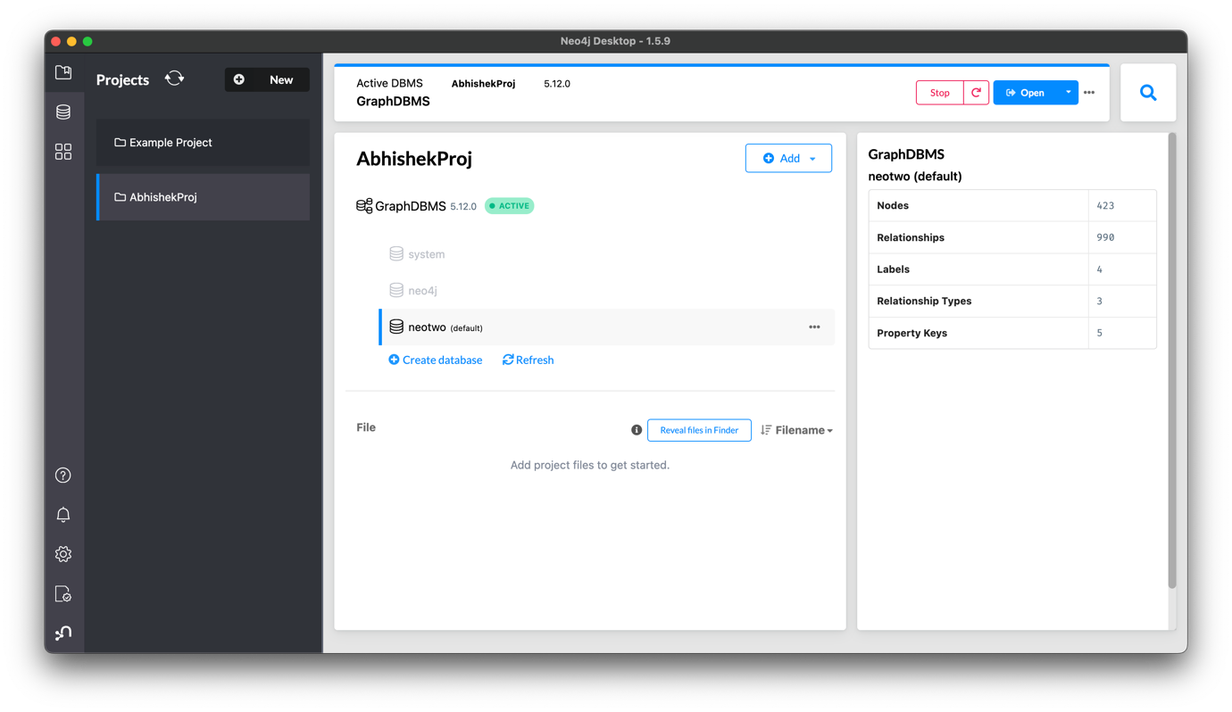Wide community support and comprehensive documentation.

Figure 1: Neo4j Desktop Project workspace.

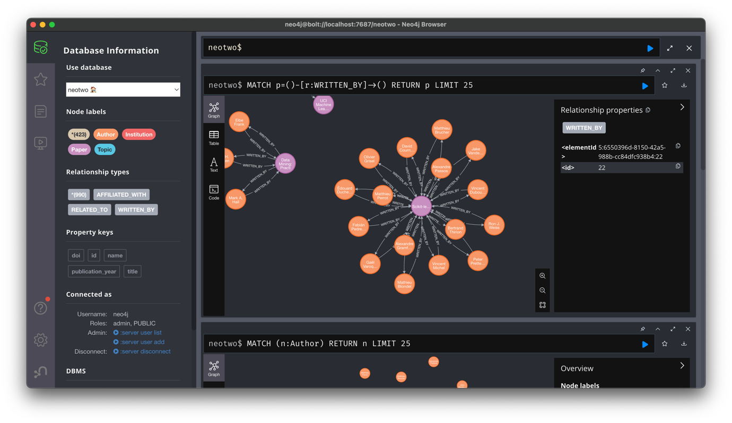Figure 1a: Neo4j Browser workspace.

**Backend Framework: Flask**

Flask is a lightweight, Python-based web framework used for building the backend of the application. It acts as the bridge between the user interface and the graph database, processing user requests and delivering the desired data.

**Key Features of Flask:**

* **Minimalist Framework:** Offers simplicity without compromising on extensibility, making it easy to customize.
* **Integrated Development Server:** Facilitates rapid prototyping and debugging.
* **Rich Ecosystem:** Provides access to numerous extensions for features like database integration and authentication.

**Why Flask?**

* Easy integration with Python libraries like PyVis and NetworkX.
* Flexibility to build RESTful APIs and custom routes.
* Suitable for small to medium-scale applications with a focus on rapid development.

**Frontend Technologies**

The frontend of the Research Insight Explorer is designed to ensure a seamless and intuitive user experience. It includes the following components:

1. **HTML/CSS**:
   * HTML provides the structural framework for the web pages.
   * CSS is used to enhance the visual appeal, ensuring the interface is clean and responsive.
2. **Bootstrap**:
   * A frontend library for creating responsive and mobile-first designs.
   * Ensures the application is accessible across devices of varying screen sizes.
3. **Jinja2**:
   * The templating engine integrated with Flask for rendering dynamic content.
   * Allows data retrieved from the Neo4j database to be displayed in real-time.

**Visualization Tools**

Visualization is a critical component of this project, enabling users to explore the dataset interactively. The following tools were utilized:

1. **PyVis**:
   * A Python library for creating interactive network graphs.
   * Allows users to visually explore nodes (authors, papers, topics) and their relationships.
2. **NetworkX**:
   * Provides a foundation for graph analysis and manipulation.
   * Used to preprocess the graph data before visualization.

**Programming Language: Python**

Python serves as the primary programming language for the project, offering a wide array of libraries and frameworks for each stage of development.

**Why Python?**

* Rich ecosystem of libraries for data manipulation (Pandas), visualization (Matplotlib, PyVis), and database integration (Neo4j driver).
* Easy learning curve and strong community support.
* Seamless integration with Neo4j via the neo4j Python driver.

**Neo4j Python Driver**

The Neo4j Python driver acts as the connector between the Flask backend and the Neo4j database. It enables efficient execution of Cypher queries and data retrieval.

**Key Features:**

* Supports both transactional and auto-commit executions.
* Provides a secure connection to the Neo4j database.
* Ensures compatibility with Python applications.

**Development and Deployment Tools**

1. **Integrated Development Environment (IDE):** Visual Studio Code (VS Code) was primarily used for coding and debugging due to its extensive plugin support and user-friendly interface.
2. **Version Control:** Git was used for tracking changes and managing code versions.
3. **Local Deployment:** Flask’s built-in development server facilitated testing during development.
4. **Data Preprocessing Tools:**
   * **Pandas:** For cleaning and restructuring the raw data retrieved from OpenAlex.
   * **JSON:** For handling and parsing the raw dataset format.

**Hosting and Deployment**

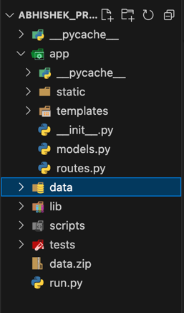The application was developed for local deployment, but its architecture is designed to be easily scalable for cloud hosting services like AWS, Google Cloud.

Fig-2: Project Structure

**System Architecture**

The Research Insight Explorer is built on a robust architecture that integrates multiple components to ensure seamless functionality and scalability. This section outlines the architectural design, detailing the interaction between the backend, frontend, and graph database.

**Overview**

The system architecture follows a modular design, dividing the application into three primary layers: the database layer, the application logic layer, and the presentation layer. Each layer has a distinct role, ensuring flexibility and maintainability.

**Database Layer**

At the core of the architecture is the Neo4j graph database. The database is modeled to capture the relationships between authors, papers, topics, and institutions. The property graph model used by Neo4j enables efficient traversal and querying of interconnected data. Nodes in the database represent entities such as authors, papers, and topics, while edges capture relationships like "WRITTEN_BY" and "RELATED_TO". This structure is highly suited for answering complex queries such as finding co-authorship networks, identifying trends in research topics, or exploring the connections between institutions and publications. The database is preloaded with data processed from OpenAlex, which ensures consistency and accuracy in representing academic research data.

**Application Logic Layer**

The application logic layer is implemented using Flask, which acts as the central hub connecting the database and the frontend. It handles user requests, processes queries, and formats the retrieved data for display. This layer also includes various Python functions to execute Cypher queries in Neo4j and perform additional data processing. The logic layer ensures a smooth flow of information by:

* Managing user inputs, such as search terms or filter parameters, and validating them.
* Constructing and executing Cypher queries to fetch the required data from Neo4j.
* Aggregating and transforming the data into a format suitable for visualization and display.
* Handling exceptions and ensuring robustness in query execution.

**Presentation Layer**

The presentation layer is responsible for delivering a user-friendly interface to interact with the system. Built using HTML, CSS, and Bootstrap, the frontend provides dynamic content rendering through Flask's Jinja2 templating engine. Key features of the presentation layer include:

* A home page with navigation buttons leading to different functionalities like search and visualization.
* A search interface allowing users to filter papers by topic, author, publication year, and more.
* A results page displaying search outputs in a readable format, with clickable links to view detailed information about specific papers.
* An interactive visualization page where users can explore relationships between entities through an interactive graph generated using PyVis.

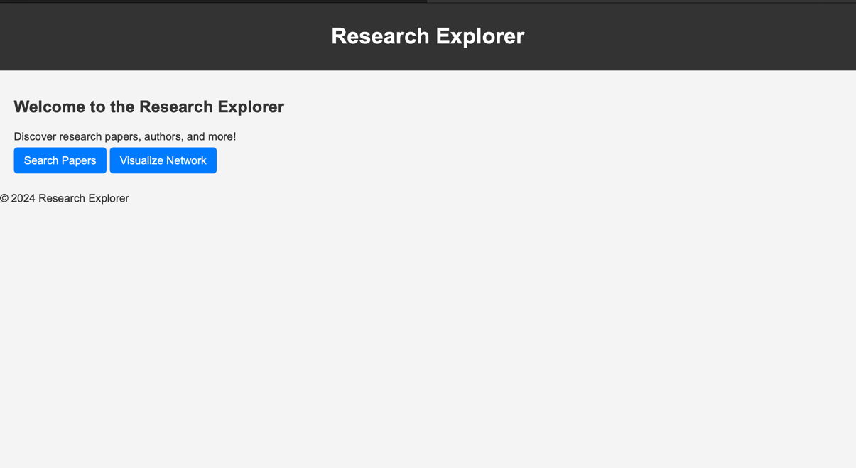

Figure 3: Home Page of Research Insight Explorer

**Data Flow**

The data flow in the system is as follows:

1. The user interacts with the frontend, entering search queries or selecting filters.
2. The application logic layer processes the input and translates it into Cypher queries.
3. Neo4j executes the queries and returns the results to the application logic layer.
4. The data is formatted and sent to the frontend for display or visualization.
5. In case of visualizations, the graph data is processed using NetworkX and PyVis to create an interactive network graph, which is then embedded in the web page.

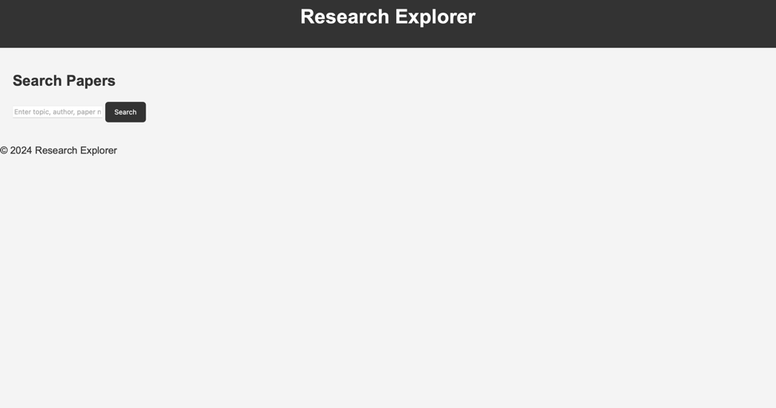

Figure 4. Search Paper feature page.

**Key Architectural Decisions**

Several key decisions were made to optimize the system architecture:

* **Graph Database Selection**: Neo4j was chosen for its ability to model complex relationships and execute traversal-based queries efficiently.
* **Flask for Backend**: Flask’s lightweight nature and compatibility with Python made it ideal for implementing a modular and extensible backend.
* **Interactive Visualization**: PyVis was selected to provide an engaging user experience, enabling users to explore graph data dynamically.
* **Responsiveness**: Bootstrap was utilized to ensure the application works seamlessly across various devices and screen sizes.
* **Data Preprocessing**: Raw data from OpenAlex was preprocessed and transformed into a structure suitable for Neo4j to enhance query performance and reliability.

**Advantages of the Architecture**

The modular architecture of the Research Insight Explorer ensures:

* **Scalability**: Additional features or functionalities can be integrated without affecting the existing components.
* **Efficiency**: Neo4j’s graph-based queries and Flask’s lightweight server ensure quick response times.
* **Interactivity**: The system’s design allows users to explore data visually, making it more engaging and insightful.
* **Maintainability**: Clear separation of concerns between the database, application logic, and presentation layers simplifies debugging and future development.

**Backend Development with Flask**

The backend of the Research Insight Explorer is the backbone of the system, facilitating data management, query execution, and integration between the Neo4j database and the frontend. It has been meticulously developed using Flask, a lightweight yet powerful Python web framework. This section delves into the backend's design, its core functionalities, and the rationale behind key implementation decisions.

**Framework Selection**

Flask was chosen for backend development due to its simplicity, flexibility, and extensibility. Its minimalistic nature enables developers to build modular applications with ease, while its compatibility with Python aligns with the Neo4j Python driver for seamless database interactions. Flask also supports integration with Jinja2 for dynamic HTML rendering, making it a suitable choice for building the Research Insight Explorer.

**Core Components**

The backend is structured into several components, each handling specific responsibilities. These components include:

1. **Routes**
   * The routes.py file defines the endpoints for the application, handling requests from the frontend and invoking appropriate functions from the models.
   * Key routes:
     + /: Serves the home page with navigation links to different features.
     + /*search*: Processes user queries for papers, topics, and authors, returning filtered results.
     + */details/<paper_id>:* Displays detailed information about a specific paper.
     + */visualize:* Generates interactive visualizations for exploring entity relationships.
2. **Models**
   * The models.py file encapsulates all database-related operations. It defines functions for executing Cypher queries on Neo4j and formatting the results.
   * Key functions:
     + *search_papers(query):* Executes a search query based on user input and retrieves matching papers along with related details.
     + *get_paper_details(paper_id):* Fetches comprehensive information about a specific paper, including its authors and related topics.
     + 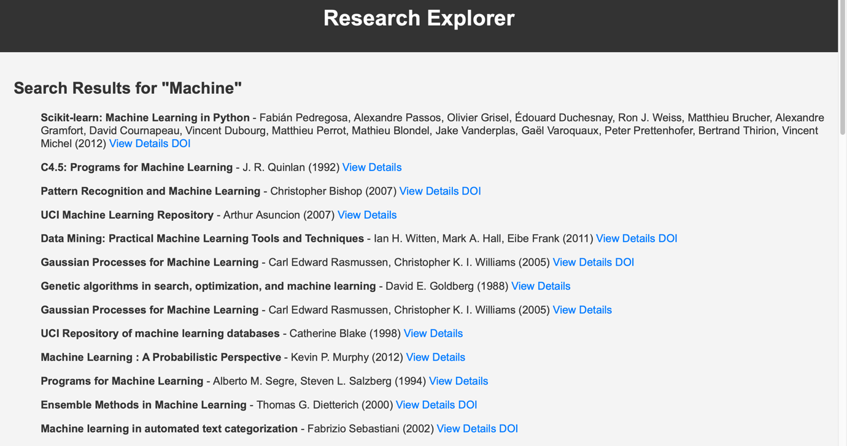*generate_interactive_graph():* Creates an interactive graph visualization using PyVis, representing relationships between authors, papers, and topics.

Figure 6: Search results using keyword.

1. **Database Connection**
   * The backend establishes a connection with the Neo4j database using the official Neo4j Python driver.
   * A centralized driver object is used to manage sessions and ensure efficient query execution.

**Functionality Implementation**

The backend's functionality revolves around three key areas: search, detailed views, and visualizations.

1. **Search Functionality**
   * Users can search for papers based on various criteria, including author names, topics, and publication years.
   * The *search_papers()* function dynamically constructs Cypher queries to fetch relevant data. For instance:

*{*

*MATCH (p:Paper)-[:RELATED_TO]->(t:Topic), (a:Author)-[:WRITTEN_BY]->(p)*

*WHERE toLower(t.name) CONTAINS toLower($search_query)*

*OR toLower(a.name) CONTAINS toLower($search_query)*

*RETURN p.title, p.publication_year, COLLECT(a.name), p.id, p.doi*

*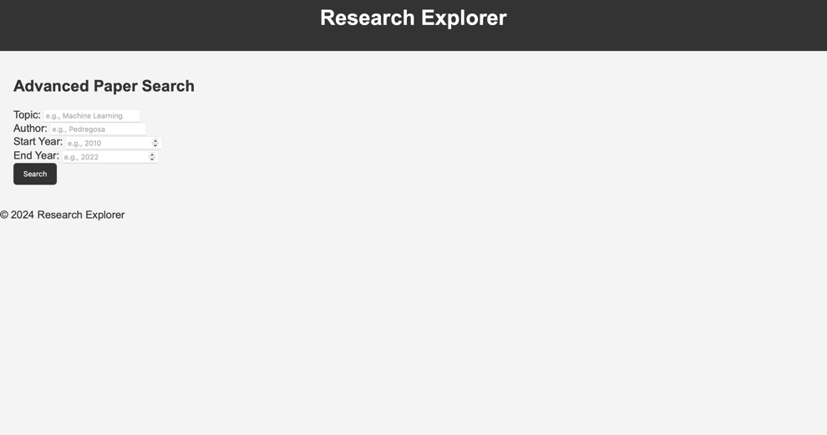}*

Figure 7. Advanced Search using filters.

1. **Detailed Paper View**
   * Clicking "View Details" for a paper directs users to a detailed view page.
   * The *get_paper_details()* function retrieves information about the selected paper and its authors:

*{MATCH (p:Paper {id: $paper_id})-[:WRITTEN_BY]->(a:Author)*

*RETURN p.title, p.publication_year, COLLECT(a.name), p.doi}*

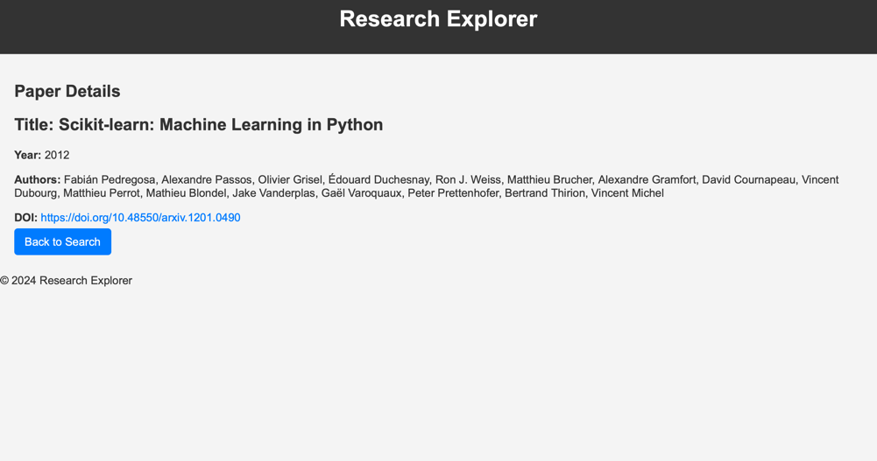

Figure 8. Detailed Paper view page.

1. **Interactive Graph Visualization**
   * 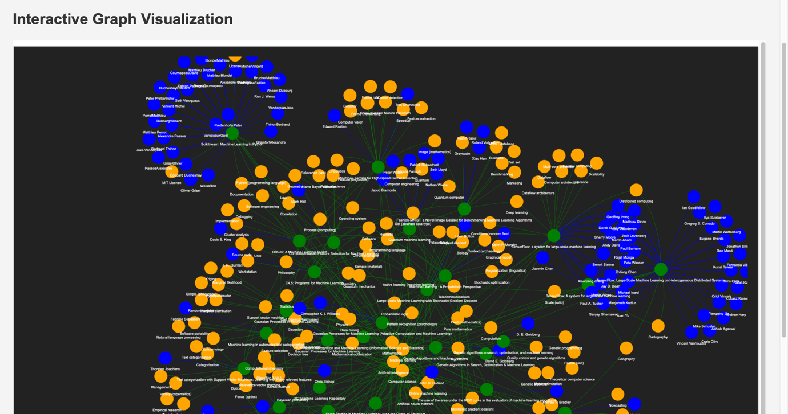The generate_interactive_graph() function uses PyVis to create a dynamic graph showcasing relationships between authors, papers, and topics. It allows users to interactively explore the network structure.

Figure 9. Interactive Graph Visualization page.

**Error Handling and Debugging**

The backend incorporates robust error-handling mechanisms to ensure smooth operation:

* Validation checks for user inputs to prevent malformed queries.
* Try-except blocks around database interactions to handle connection errors or invalid queries.
* Debugging statements (e.g., logging query inputs and results) to facilitate troubleshooting during development.

**Performance Optimization**

To enhance performance, the following strategies have been adopted:

* **Query Optimization**: Cypher queries are written to minimize traversal depth and reduce the number of intermediate results.
* **Caching**: Frequently accessed data, such as the list of authors or topics, can be cached to avoid redundant database calls.
* **Connection Pooling**: The Neo4j driver manages a pool of connections to ensure efficient resource utilization.

**Security Considerations**

The backend is designed with security in mind:

* User inputs are sanitized to prevent injection attacks in Cypher queries.
* Sensitive information, such as database credentials, is stored securely using environment variables.
* HTTPS is recommended for deployment to encrypt data in transit.

**Integration with Frontend**

The backend integrates seamlessly with the frontend via RESTful endpoints:

* Data fetched from the database is formatted as JSON and passed to the frontend for rendering.
* Jinja2 templates enable dynamic content generation for HTML pages, ensuring a responsive user experience.

**Scalability**

The modular design of the backend allows for easy extension:

* New endpoints can be added to support additional features, such as recommendations or citation analysis.
* The architecture supports integration with other data sources, enabling further enrichment of the graph database.

**Frontend Design and Integration**

The frontend of the Research Insight Explorer serves as the interface between the user and the application. It has been designed to be intuitive, visually appealing, and responsive, providing seamless access to the backend functionality. This section details the tools, design considerations, and implementation strategies employed in developing the frontend.

**Technology Stack**

The frontend of the Research Insight Explorer is developed using HTML, CSS, and Jinja2 templating. The choice of these technologies aligns with the Flask framework, allowing dynamic content rendering and integration with backend data. Bootstrap is used to enhance the visual appeal and responsiveness of the application.

1. **HTML**: Provides the structure of the web pages.
2. **CSS**: Ensures a visually appealing design and layout customization.
3. **Jinja2**: Enables dynamic content generation by embedding backend data into HTML templates.
4. **Bootstrap**: Adds modern styling and responsive design to the application.

**Page Structure**

The frontend consists of the following key pages:

1. **Home Page**
   * Purpose: Provides a welcoming interface with navigation options.
   * Content:
     + A welcome message highlighting the application’s purpose.
     + Navigation buttons leading to various features, such as "Search Papers," "Advanced Search," and "Visualizations."
   * Example HTML Code:

*<div class="jumbotron text-center">*

*<h1>Welcome to Research Insight Explorer</h1>*

*<p>Your gateway to exploring research knowledge graphs.</p>*

*<a href="/search" class="btn btn-primary">Search Papers</a>*

*<a href="/advanced-search" class="btn btn-secondary">Advanced Search</a>*

*<a href="/visualize" class="btn btn-info">Explore Visualizations</a>*

*</div>*

1. **Search Page**
   * Purpose: Allows users to perform simple keyword-based searches.
   * Features:
     + Input field for entering keywords related to papers, authors, or topics.
     + Results are displayed as a list, with each entry linking to the detailed view of the paper.
2. **Advanced Search Page**
   * Purpose: Offers filters for more refined searches.
   * Features:
     + Filters for topics, author names, publication years, and more.
     + A form with multiple input fields for users to specify search criteria.
   * Example Implementation:

*<form action="/advanced-search" method="POST">*

*<input type="text" name="topic" placeholder="Topic">*

*<input type="text" name="author" placeholder="Author">*

*<input type="number" name="year_from" placeholder="From Year">*

*<input type="number" name="year_to" placeholder="To Year">*

*<button type="submit" class="btn btn-primary">Search</button>*

*</form>*

1. **Results Page**
   * Purpose: Displays search results in a user-friendly manner.
   * Features:
     + Each result entry shows the paper title, authors, publication year, and links to "View Details" or the paper's DOI.
     + Pagination for large result sets.
2. **Details Page**
   * Purpose: Provides in-depth information about a specific paper.
   * Features:
     + Paper title, authors, publication year, topics, and a link to the DOI.
     + Option to navigate back to the search results.
3. **Visualization Page**
   * Purpose: Displays interactive graph visualizations.
   * Features:
     + Embeds the PyVis graph within the page.
     + Allows users to explore relationships between authors, papers, and topics interactively.

**Integration with Backend**

The frontend communicates with the backend via HTTP requests:

* **GET Requests**: Used for rendering pages such as the home page or search forms.
* **POST Requests**: Used for submitting search queries and receiving results.
* **Data Binding**: Backend data is passed to the frontend using Jinja2 templates, enabling dynamic content generation.

**Challenges and Solutions**

1. **Dynamic Data Binding**
   * Challenge: Ensuring seamless integration between backend data and frontend templates.
   * Solution: Jinja2's template rendering capabilities facilitated the dynamic display of data.
2. **Pagination**
   * Challenge: Handling large result sets without overwhelming the user.
   * Solution: Implemented pagination using Flask's request.args for smooth navigation.
3. **Interactive Graph Embedding**
   * Challenge: Displaying PyVis graphs within HTML pages.
   * 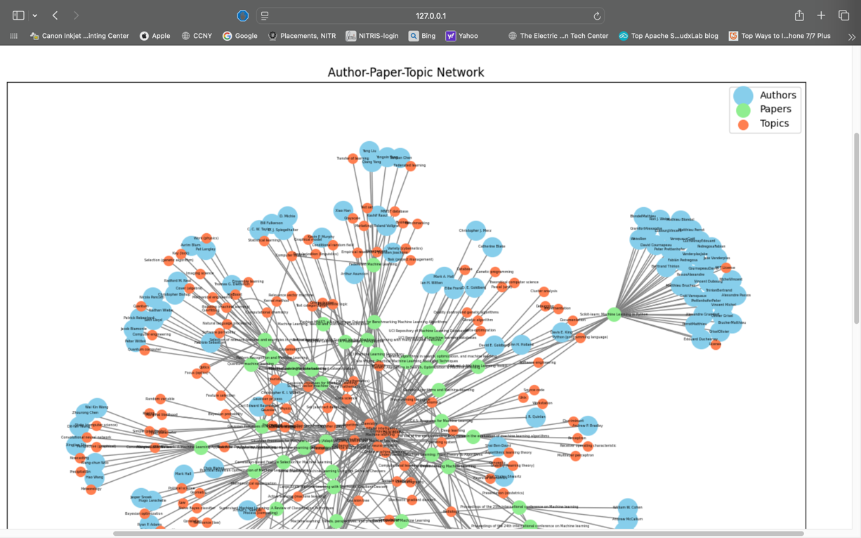Solution: Saved interactive graphs as HTML files and embedded them using iframes.

Figure 10: Graph Database Visualization.

**Conclusion and Future Work**

**Conclusion**

The Research Insight Explorer demonstrates the potential of graph databases like Neo4j in managing and exploring interconnected research data. By seamlessly integrating a backend powered by Flask with a dynamic frontend interface, the project successfully allows users to explore research papers, authors, topics, and their relationships in an intuitive and efficient manner.

The advanced features such as filtering, visualizing relationships between nodes, and detailed data exploration highlight the effectiveness of this approach. The project is designed to cater to researchers, academics, and knowledge enthusiasts, providing a valuable tool for gaining insights from interconnected research data. The user-friendly interface and interactive visualizations ensure accessibility while preserving the depth of information.

**Challenges**

1. **Data Integration**: Ensuring data consistency while importing large datasets was a significant challenge. This was addressed by preprocessing the data thoroughly before importing it into the Neo4j database.
2. **Performance Optimization**: Handling complex queries and large datasets required careful optimization of both the database structure and the queries.
3. **Frontend-Backend Integration**: Ensuring seamless communication between the frontend and backend required rigorous testing and debugging.

**Future Work**

While the project is fully functional, there are several opportunities for enhancement:

1. **Recommendation Engine**: Implementing a recommendation system to suggest related papers, authors, or topics based on user queries.
2. **Expanded Visualization**: Adding more interactive features to the graph visualizations, such as zooming, filtering, and highlighting specific paths.
3. **Data Enrichment**: Integrating additional data sources, such as citation networks, to enhance the dataset.
4. **User Authentication**: Introducing login systems to allow personalized features, such as saving favorite searches and creating custom graphs.
5. **Machine Learning Integration**: Utilizing machine learning algorithms for trend analysis, clustering topics, or predicting emerging research areas.
6. **Mobile App Development**: Extending the application to mobile platforms for wider accessibility.
7. **Integration with APIs**: Linking to APIs like OpenAlex, CrossRef, or Google Scholar to keep the dataset updated in real-time.

**REFERENCES:**

1. Elmasri, R., & Navathe, S. B. (2016). Fundamentals of Database Systems (7th ed.). Pearson.
2. Grinberg, M. (2018). Flask Web Development: Developing Web Applications with Python (2nd ed.). O'Reilly Media.
3. Neo4j Official Documentation - Graph Database Platform. https://neo4j.com/docs/
4. OpenAlex API Documentation - Open Research Data. https://docs.openalex.org/
5. PyVis Documentation - Interactive Graph Visualizations. <https://pyvis.readthedocs.io/>